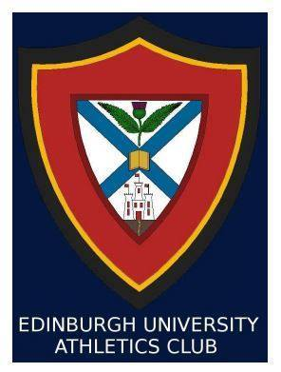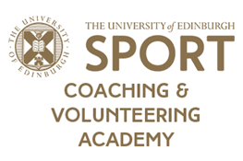

**VOLUNTEER ATHLETICS COACH NEEDED**

**Requirements and Responsibilities:**

* Level 1 coaching qualification.
* Previous experience of planning and/or delivering a coaching plan (desirable), and an understanding of both sprint and endurance running and ideally of throwing and jumping events as well; ability to lead club sessions on Wednesdays with the assistance of student training secretaries; responsibility of evaluating athlete’s performances and aiding athlete development.
* Ability to attend monthly (though flexible) coaching team meetings and be in regular communication with club’s committee.

**Benefits:**

* Access to Edinburgh University Sports Union’s Coaching and Volunteering Academy and a student priced Pleasance gym membership.
* The chance to coach high achieving athletes; financial assistance with coach education courses, where agreed appropriate.
* Free entry to all club dinners and balls; two pieces of club PlayerLayer kit; travel allowances to events.

**Club:** Edinburgh University Athletics Club (EUAC)

**Role Title:** Club Coach

**Place and Time: Saughton Sports Complex** (Edinburgh, EH11 3HB); **Wednesdays**, 3:00pm – 5:00pm (from week starting 9th September 2019); 75 hours per academic year.

*Edinburgh University Athletics Club is looking for a friendly and reliable volunteer coach to lead our Wednesday track training sessions. We are a diverse but close-knit club who cater for both those interested in general fitness and those competing on a national and international level. Our athletes are regularly medallists and finalists at competitive events such as BUCs and SUCA and we hope to not only continue this success but also widen participation in these events. We look forward to welcoming a likeminded individual with enthusiasm for the sport and a passion for athlete development.*

**Please submit your interest via e-mail to Edinburgh University Athletics Club**

**athletics@ed.ac.uk**

**Deadline for Applications: 9th September 2019**