Edinburgh University Sports Union
Intramural Small Sided Hockey Rules

Sports Union

Edinburgh University Sports Union is responsible for administering the IMS leagues and as such, all decisions taken by the IMS Committee (following consultation with VPIM or the IM coordinator) are to be abided by. The SU reserves the right to ban any participant from taking part in IMS activities for continued breach of code of conduct rules.

General conduct

Players should all wear footwear appropriate for the pitch surface and ensure the area round the pitch is left tidy. The IMS leagues are run in the spirit of good sportsmanship and this should be upheld in matches. Participants in IMS activities are representatives of Edinburgh University and as such, the conduct of players should be a credit to the University and not cause for complaint.

Cancellations

Any games cancelled by one of the teams will not be replayed except in exceptional circumstances (at the discretion of the Sports Coordinator). The score will be recorded as a 15 - 0 victory to the opposition. If you need to cancel a game you must contact ALL of the following providing them as much notice as possible.

- Ollie Cruickshank (ollie.cruickshank@ed.ac.uk) – at least 72 hours before the game to avoid paying for the pitch.
- The Vice-President Intra-Mural (eusu.vpim@ed.ac.uk) or IM Coordinator (eusu.imcoordinator@ed.ac.uk)
- The opposition Captain

- Failure to give at least 72hours notice to the Sports Union will incur a £20 fine. Failure to notify the opposition Captain will also incur a further £15 fine.

It is very important that these cancellation procedures are abided by, as failure to do so will risk the allocation of pitches to Intramural being cancelled.

Failure to give more than 72 hours’ notice for cancellations on more than 2 occasions, will incur the team being disqualified from the league without a refund.

Similarly failure to pay fines within 5 days of the invoice being raised will result in disqualification from the league, at the discretion of the Sports Coordinator and VPIM.

Results

Results should be reported as soon as possible after the game to allow League tables to be updated promptly.
The deadline for results to be reported is 10pm the day of your fixture. BOTH teams are to report the results, regardless of the outcome, to ensure consistency and make sure they are reported on time.

If the result is not reported by the deadline a 0 – 0 draw will be recorded with neither team getting a point.

This will not be reversed even if the result is subsequently submitted.

Membership

All individuals taking part in Intra-Mural competitions must purchase a Sports Union Membership available on the SU website https://www.eusu.ed.ac.uk/organisation/IntraMural/

THE GAME RULES

“The rules are the appropriate rules of 11-a-side field hockey except for the following…”

Player numbers and pitch dimensions

- This is a six-a-side game, with up to four replacements
  - The format can be played with or without a kitted goalkeeper for each team. Use of a goalkeeper by all teams will be agreed prior to the tournament, league or event taking place. There is no option to play with a kicking back
  - The format can be single-gender or mixed
    - If mixed, at least 2 players of each gender must be on the pitch at all times

- The playing area will measure 29m wide by 55m long

Scoring

- At each end, there will be a ‘Danger Zone’ 15m from the baseline of the pitch and running across the full width of the pitch. Goals may only be scored from within this zone. The normal rules affecting play in an 11-a-side pitch ‘D’ apply in this zone unless otherwise stated
  - If playing without a kitted goalkeeper, shots cannot be lifted and only count if they hit the backboard of the goal

Restarts, corners and free-hits

- In the case of any free-hit or restart being awarded, all players should be at least 5 meters away from the ball carrier
  - Defenders caught within 5 meters are not allowed to interfere with play until the ball has travelled 5 meters
  - The ball must be moved 5 meters before a shot is taken. These 5 meters can be taken directly in to the Danger Zone

- Clearance – (equivalent of a ‘16’ hit) – If the ball has travelled over the baseline and was last hit by the attacking team, play restarts with the defending team in possession on the Danger Zone line, in-line with where the ball went out of play

- Long Corner – If the ball has been unintentionally hit over the baseline by the defending team, or there is an unintentional foul by the defending team in the Danger Zone, play restarts with the attacking team in possession on the Danger Zone line in-line with where the ball went out of play or the offence took place
  - The ball must travel 5 meters before a shot can be taken. These 5 meters can be directly in to the danger zone
- Penalty corners will be replaced by a ‘Challenge’
Challenges
- The procedure for a Challenge is as follows:
  - Time and play is stopped
  - One attacking ball carrier starts with the ball 5 meters outside the Danger Zone line, on the challenge marker
  - One defending player is permitted. EITHER:
    - If a kitted goalkeeper is in play, they are the defending player. The goalkeeper must start with both feet on the goal-line. As soon as the ball has been played by the attacking player, the goalkeeper is permitted to move.
OR
    - If there is no kitted goalkeeper, one player acts as the defender. The defender starts 3 meters inside the Danger Zone line, on the challenge marker. As soon as the ball has been played by the attacking player, the defending player is permitted to move. The defender still plays as an outfield player and can only use their stick to play the ball
  - All other players must position themselves behind the half way line
  - When the attacker and defender are in place, the whistle is blown
  - As soon as the attacker plays the ball, all players are permitted to re-engage, attempt to play the ball, and open play resumes as normal
  - If an intentional foul is committed:
    - By a kitted goalkeeper, then a penalty flick will be awarded
    - By the appointed defender, then a Penalty Stroke will be awarded
      - If there are no goalkeepers, the stroke must still hit the backboard of the goal to score
Kitted Goalkeeper
Defender
OR
Attacking Player with Ball
Other 5 players from each team can start anywhere in this half
Fig. 1.1 – Possible player starting positions for a Challenge

Key
Danger Zone Line
Challenge Marker
Attacker
Defender
Possible Movement

Fig. 1.2 – Possible player movement as attacker plays the ball
Kitted Goalkeeper
Defender
OR

Duration
Match duration can be flexible to the pressures of facility availability and team numbers. However, the format is designed to be high-paced and high-intensity. Therefore:
- The standard recommendation for game time is 24 minutes. This can be split as either:
  - Two halves of 12 minutes, with a 4 minute half time break (Total = 28 minutes)
  - Four quarters of six minutes, with a 1 minute tactical quarter break and a 4 minute half time break (Total = 30 minutes)

For tournament structures, to fit in more games, the following can be used:
  - Two halves of 6 minutes, with a 3 minute half time break (Total = 15 minutes)

Officiating
- All mid- to high- level competitions are expected to have at least one umpire per game.
There are also the following recommendations:
  - High level competitions are strongly recommended to have two umpires per game
  - All other competition levels are recommended to have at least one umpire per game, and two if available
  - Low-level/recreational competitions and social sessions can be self-umpired

Pitch Markings
The diagram below (Fig. 2) shows how the three Small Sided pitches overlay on to a normal 11-a-side pitch. Key things to note are:
- Danger Zone lines should be marked using throw-down rectangular markers. Each line is recommended to consist of 4 orange markers each side of a single yellow marker, which denotes the middle of the pitch. The Challenge markers should be in line with the central yellow marker and the appropriate distance either side of the Danger Zone line
- Danger Zone lines can use the 11-a-side penalty corner injection mark to denote the start and end of the line across the three pitches
  - If playing without a kitted goalkeeper, the Danger Zone can be shortened to 10m high. This can be achieved by using the starting point of the 11-a-side ‘D’ to denote the start and end of the line across the pitch
- There is a 2 metre run-off zone between each pitch
- Side lines can be marked in two ways:
  - First preference is to have a piping barrier (or other low barrier), attached to the fence at each end. The barrier is part of the field of play, and play does not stop if it hits the barrier. 6 barriers would be needed to mark out all three pitches
  - Second preference, if limited barriers are available, is to use normal sports cones to mark the side lines and put a single barrier in the 2 meter run-off between each pitch. This is not part of the field of play, and is there to stop balls moving between pitches. 2 barriers would be needed in total
  - Final preference, if barriers are not available, is just to use normal sports cones
If your pitch has four floodlight towers along the side of the pitch, these will be at approximately the right distance for each 2 metre run-off, and the side lines can be marked either side of these

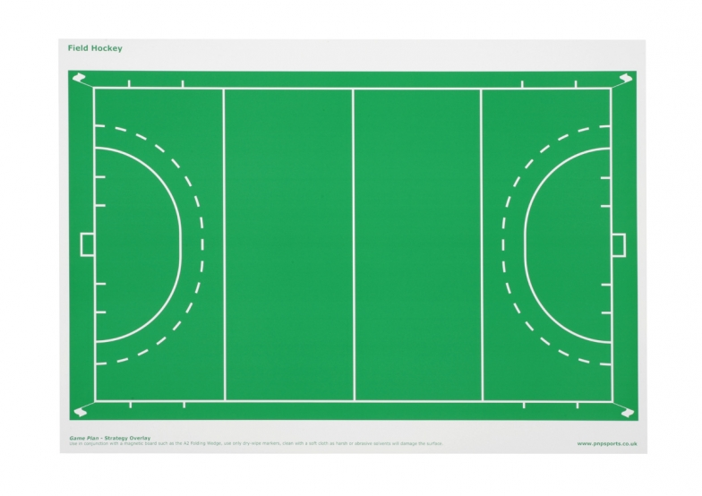
29m
2m
15m
5m

3m
15m
5m

3m
Danger Zone
Danger Zone
2m
55m
Fig. 2 – Three Small Sided Pitches marked on an 11-a-side pitch
Defender Challenge Marker
Danger Zone Line
Attacker Challenge Marker

